**Pocket Patient**

*Team Project Number SP22-11*

Team members: Jihao Yang, Rui Zhang, Zhihang Liu, Yuxi Yang, Mingkun Sun

Adviser(s): Dr. Anthony M. Tobia, Prof. Hajar Shirley, Sasan Haghani, Chung-Tse Michael Wu

Submitted in partial fulfillment of the requirements for senior design project

Electrical and Computer Engineering Department

Rutgers University, Piscataway, NJ 08854

**Abstract**—Medical school students specializing in psychiatry undergo four years of training, with the first two years primarily focused on acquiring basic knowledge. During this time, they have limited exposure to real clinical settings or rotations. The Pocket Patient is a website application designed to address the challenges faced by medical students, such as limited patient exposure, insufficient guidance, and delayed feedback from supervisors. Pocket patient simulates a virtual patient with a different set of symptoms and talks with users using natural language, after users input their diagnosis and treatment, timely feedback is given. To achieve that goal, OpenAI API for NLP (natural language processing) is implemented in this project and embedded into the website for simulating virtual patients and giving feedback.

**Keywords**—ChatGPT, AI, psychiatric training, medical school, website development

# **I.** **Introduction**

Mental illnesses have become one major problem in modern society and are trigging more and more attention in recent years. According to Forbes health [7], In 2020, 21% of U.S. adults (52.9 million) experienced a mental health condition. Due to the COVID-19 pandemic, depressive symptoms grew from a base of about 193 million people worldwide to 246 million, which is about 28%. Anxiety disorders grew from about 298 million people affected to 374 million, which is about a 25% increase. This makes psychiatrists in great demand and importance.

Psychiatry is a medical specialty focused on diagnosing, treating, and preventing mental, behavioral, and emotional disorders [5]. Mental status examination is an essential topic in psychiatric training. The mental status examination is a structured assessment of the patient's behavioral and cognitive functioning. It includes descriptions of the patient's appearance and general behavior, level of consciousness and attentiveness, motor and speech activity, mood and affect, thought and perception, attitude and insight, the reaction evoked in the examiner, and, finally, higher cognitive abilities. The specific cognitive functions of alertness, language, memory, constructional ability, and abstract reasoning are the most clinically relevant [9]. According to the Diagnostic and Statistical Manual of Mental Disorders (DSM) – a handbook widely used by clinicians and psychiatrists in the United States to diagnose psychiatric illnesses, common mental illness include anxiety, depression, personality disorders, schizophrenia, bipolar disorder, eating disorders, and addiction, etc [6]. However, the assessment and diagnosis of mental health disorders is ambiguous, inconsistent, and negatively biased frustrating efforts to identify underlying etiologies and appropriate intervention. Mental illnesses can share some, or at least behave the same symptoms. Different mental illnesses can also co-exist. And the treatments for different kinds of mental illnesses are usually very different from each other. The ambiguity in characterizing and diagnosing mental health disorders according to different sets of symptoms is a major problem that demands lots of training and research. For example: borderline personality disorder (BPD) is a serious mental illness characterized by dysregulation of emotions and impulses, an unstable sense of self, and difficulties in interpersonal relationships, often accompanied by suicidal and self-harming behavior. Major depressive disorder (MDD) commonly co-occurs with BPD. Patients with BPD often present with depressive symptoms. It can be difficult to distinguish between BPD and MDD, especially when the two disorders co-occur. When MDD and BPD co-occur, both conditions should be treated concurrently. MDD co-occurring with BPD does not respond as well to antidepressant medication as MDD in the absence of BPD [10]. Therefore, extensive training, research and clinical experiences are crucial in this field.

For psychiatrists training in medical school in the US, medical students follow a standard curriculum. In addition to anatomy, biochemistry, and physiology, students take courses in psychiatry, behavioral science, and neuroscience in the first two years of medical school. In the last two years, students are assigned to medical specialty clerkships where they study and work with physicians in at least six different medical specialties, including psychiatry [8]. This step is called clinical rotation, at this stage they gain real world experience regarding psychiatric diagnosis and treatments.

Medical students are faced with a range of challenges and difficulties during their study due to the current academic structure and curriculum. The first two years are solely based on exam preparation, which means they have no exposure to real patients until the third year. Most students are not prepared with real clinical diagnosis and treatments before they enter clinical rotations. And even after they are doing clinical rotations, they still have limited access to real clinical settings (according to time / supervisor availability), lack of guidance and support from their supervising physicians or other healthcare professionals as well as lack of timely or constructive feedback on their performance. They may also be faced with interpersonal challenges for difficult patients or communication barriers, etc.

In summary, this project, the Pocket Patient, will act as a supplementary tool aiming at improving the problems mental status examination as well as limitations psychiatric training processes medical school students are facing. The targeting groups include but are not limited to students. Any practitioner can benefit from the project. Pocket Patient will give psychiatrists more opportunities in practicing their real-world mental status examination skills at the website anytime and anywhere; help them with more knowledge, clinical diagnosis, and treatment techniques, improving their diagnosis and treatment success rate.

**II.** **Methods / Results (any relevant) / Approach**

**2.1 Methods:**

**Conceptual Design:**

The Project Pocket Patient is focusing on the simulation of interactive diagnosis of mental disorder patients. The reason why choosing the mental disorder rather than normal physical disease is that the physical disease is usually measured by the various body index and image illustrations that are generated by sophisticated machines such as X-ray. Therefore, to simulate physical disease in software is difficult but most mental disorders can be described by texts which is easier to use the language models to process data. In the very beginning, one proposed solution is to use an individual language model and train it by the acquired official medical record of mental disorder patients and simulate the conversation in an application in the mobile smart device such as phones and tablets. However, this method is facing the two problems which were realized during the development of it. Firstly, it’s hard to acquire the official medical record of mental disorder patients because of the legal issues and privacy compromise. Secondly, none of the team members is familiar with the mobile platform application development which will cost significant time to do self-learning without proper instruction. This proposal is eventually given up. An improved proposal is applied instead. The patient can be simulated by the language model powered by OpenAI which has extremely powerful models and tremendous amounts of trained data. And instead of a mobile platform application, the team decided to develop the web pages because few team members have experience of HTML languages and websites that can be accessed by any browsers such as Microsoft Edge, Google Chrome, Safari, etc in both stationary and mobile platforms. After a simple test (Run the language model locally and do simple conversation like saying “ how are you”, “what are the symptoms of anxiety disorder”) in the local import of OpenAI API by Python. This approach is proven feasible. 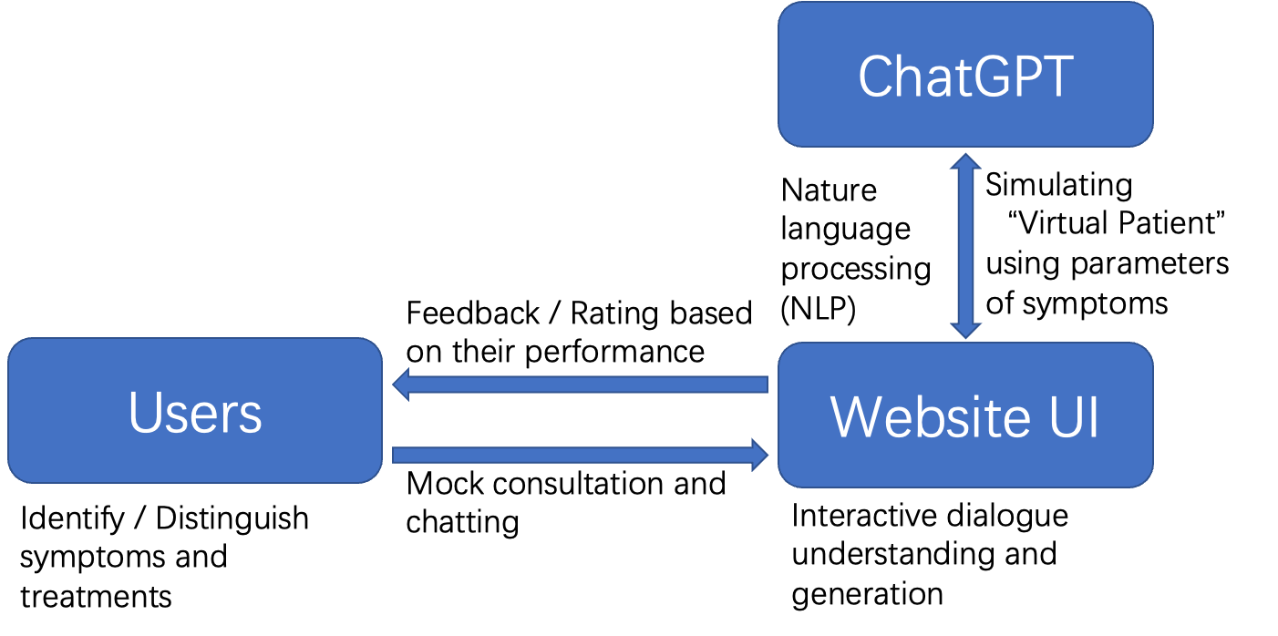

Fig.1. Basic Structure of Pocket Patient

Illustrated by Fig.1. The OpenAI language model will handle the input entered in the website from the users and generate responses that will be displayed on the website as well. To begin the simulation. The website will display the symptoms of a random mental disorder and wait for the user to enter the corresponding name of the disorder and treatment. The model will determine whether the answer is correct or not and explain the reason and restate the correct answers for better memorizing and understanding. Users can go as many rounds as they like and end whenever they want.

**Detailed Design:**

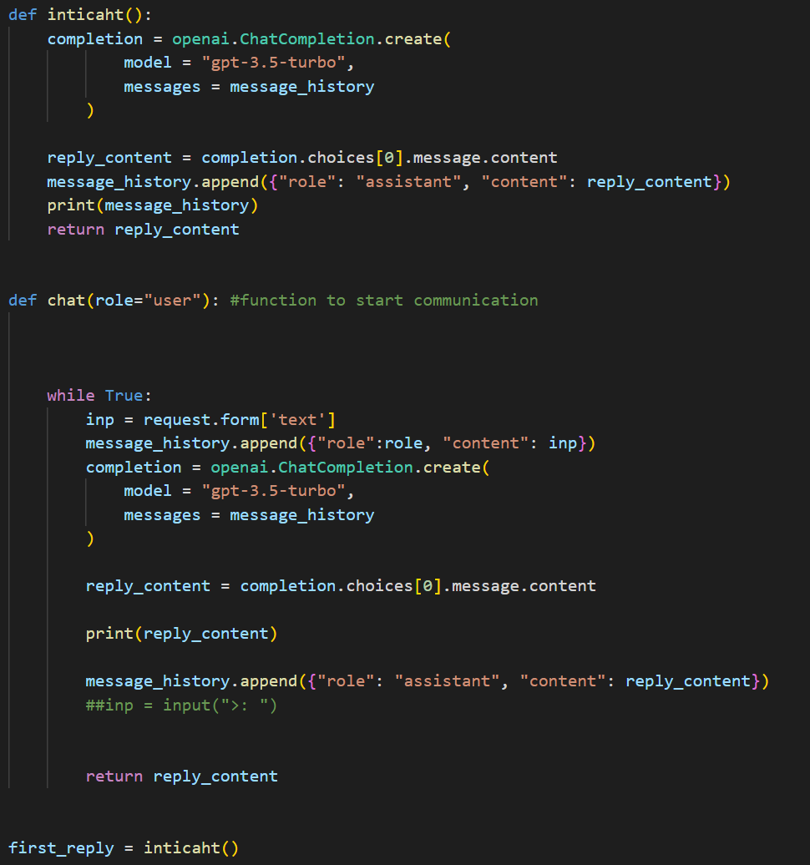

Fig.2. Final Code Implementation of Language model

The project Pocket Patient will be implemented in software and therefore there are no hardware requirements for this project. The tool that we are using for development is VScode and standardized programming languages Python and HTML & CSS. Therefore, the project needs the basic knowledge of programming and the symptoms of common mental disorders and their treatment which are collected through two clinic websites: mayo clinic [1] and cleveland clinic [2]. Python code is mainly used on machine learning and AI relevant tasks and most of the team members have written python code before. It’s more efficient for the team to communicate and work together. And HTML & CSS is used to write web pages and style the individual components. The first task of the project is to tune the model to behave as desired, which is also a challenge in the first place. To figure out how to use the language model locally, we study the OpenAI API [3] and the gpt-3.5-turbo engine [4]. The model generates the response based on the unique data structure which consists of 2 parts, “role” and “content”, shown by the Fig.2. The “role” is the message sender, “user” stands for the user who is inputting texts and “assistant” stands for the model itself. The “content” is basically the content of messages. However, the model can only respond to user input for once. To make it can interact like in a conversation based on a theme. There must be a loop and a list to store the conversation information so that the model can give the right response based on the previous messages. The Function “inticaht()” in Fig.2 will initialize the conversation based on a certain theme. And the “message_history” is a list declared as the global variable that stores the conversation data structures. At this time, the program will display the symptoms of a mental disorder and users need to enter the name of the disorder and right treatment. Then the “chat()” function in Fig. 2 will run. There’s a while loop that could repeat the process that model makes response to the users’ input. And therefore to create the simulation of conversation. To state the theme of conversation and make the model display the symptoms, we have to do prompt engineering which means to work on the very first content that is taken by the model. It can be done by experimenting with different phrases and seeing which one will make the model generate the most desirable and stable content. But it’s very time consuming. It took approximately one week to finally determine the final prompt. And to make sure the model gives the right comments to the user's answers, we have to check it by comparing it with data of symptoms and treatments that we previously collected. Initially, we wish to make the model behave like a real patient, but this can only be achieved by a highly intelligent machine and it requires various knowledge that is beyond our capabilities. And the best solution we can give is to make the user answer the question to simulate the diagnose process.

While the backend of the application is attached to GPT api, the frontend of pocket patient was decided to be made as a website. Our original intention was to create a cell phone software but the idea was soon abandoned mainly because our team members are not familiar with mobile development platforms. We eventually decided to use html language to implement the web page and flask package in python to create the web application.

The website application is implemented with the python package flask. The website is composed of two pages: a main page and a chat page. A url link is first generated and can be reached through a click, and the user is then directed to the main page. The function of the main page is to initialize the chatbot, the user can send any hello message to the bot like “hi”, “hello”, “Let’s begin!” to activate the program, and then the pocket patient will start.

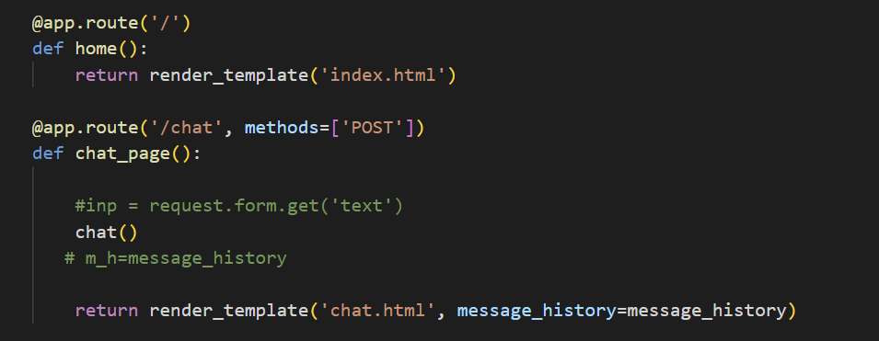

Fig3. code to activate the two website pages.

Here, index.html is the main page and chat.html is the chat page where the pocket patient program operates.

**Experiment/Product result:**

Before the actual implementation, we first created a local version of pocket patient to test on user interface design and backend - frontend interaction.

In this version, we have tested multiple times and found out that the behavior of the chatbot is unstable. Sometimes it is answering its own question and sometimes it asked user for symptoms. After a period of debugging we realized that this is due to some errors managing the message history when the model is attached to user interface. The behavior of the chat model is largely dependent on the message history, as the model initializes with a text input an error occurred therefore messing up the message history. We made a sequence of adjustment about the formation of message history and eventually got the local version to run stably: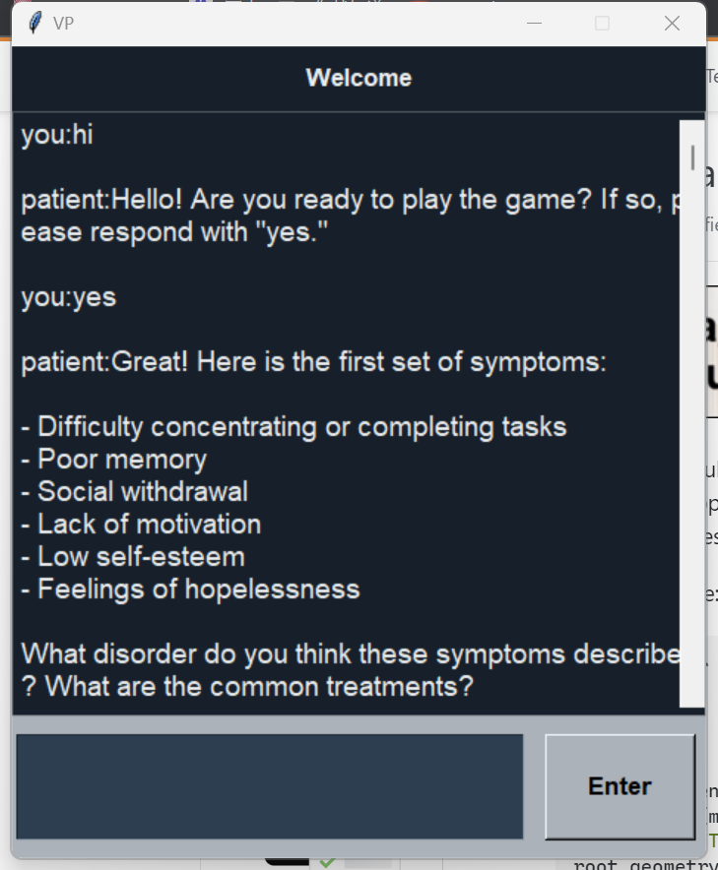

Fig 4. Test version

The web version of the application adopted a similar logic, after some adjustments with styles, the final product looks like this:

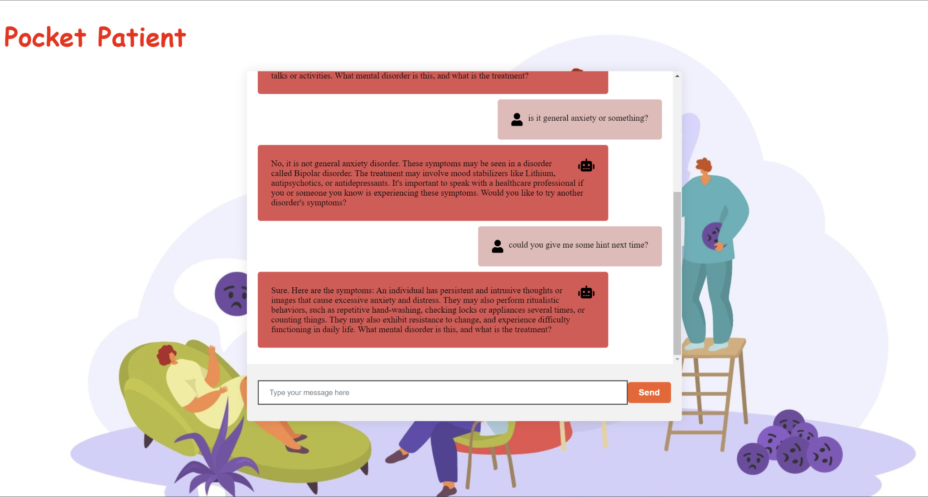

Fig5. Final version

Message from the bot is displayed on the left side of the chatbox and a simple robot icon is used to represent the bot, human message input is displayed on the right side of the box and a human icon is used to represent the human. The user can send a message through the text input below and use the scroll bar to check previous messages. The bot will start the conversation first with questions asking the user to tell the type of disorder, or ask if the user is ready to begin, the user will provide his/her diagnosis to the bot and the bot will check if the answer is correct. The user can also ask for hints when symptoms are confusing. The bot will also provide additional explanations when the user's answer is partially correct.

**3.** **Cost and Sustainability Analysis**

1. Economics (cost) impact:
   1. Prototype design and production cost:

The main cost for Prototyping the product is the ChatGPT OpenAI API cost, which costs our team $0.84 total.

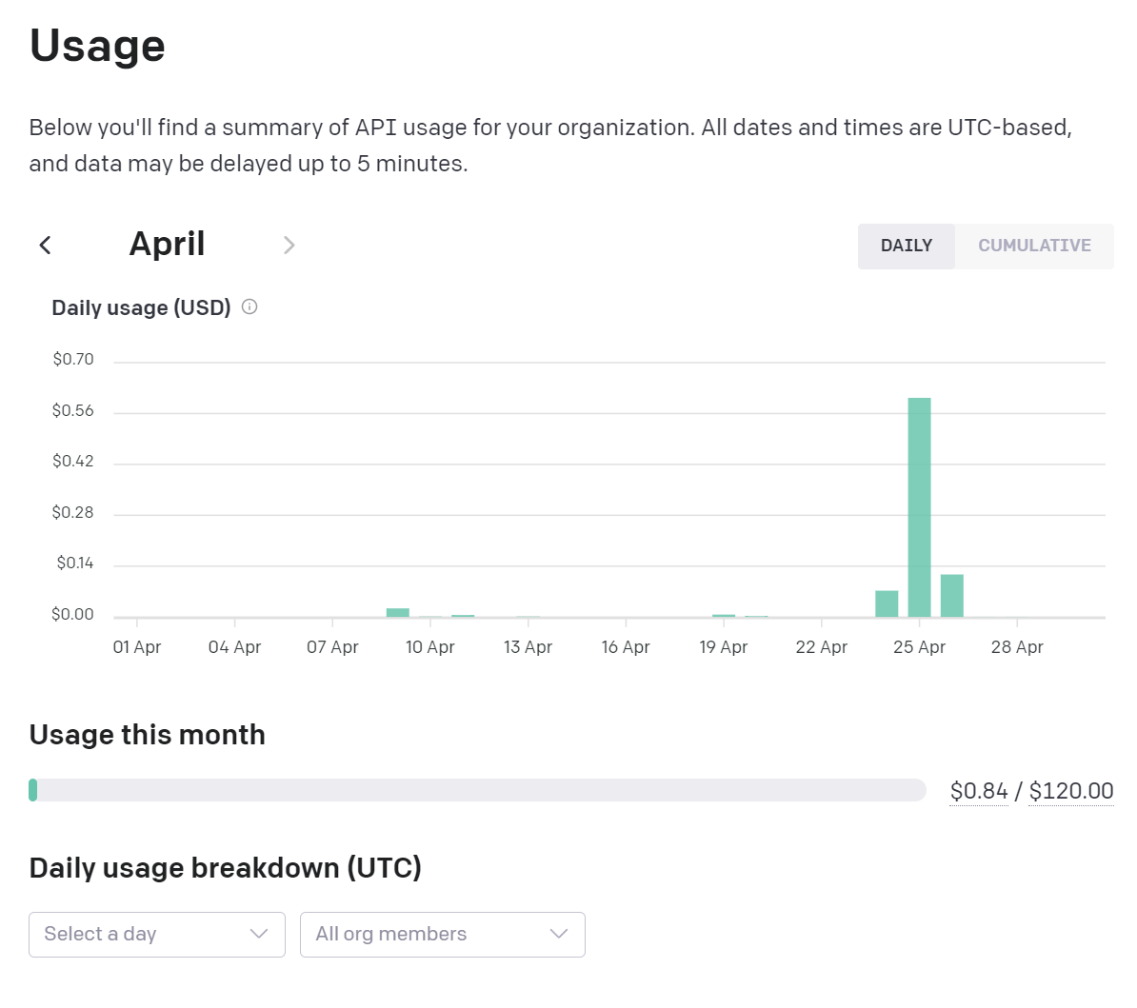

Since we programmed the programs ourselves and designed and built the website to use the service ourselves, programming and website design didn’t cost us any money.

* 1. Device cost in mass production

In mass production, we would need to buy a domain so that people could access our service to practice via the domain address. The domain name pocketpatient.xx (where .xx could be .org, .net, .us) on google domains are priced between 7$ - 350$ per year.

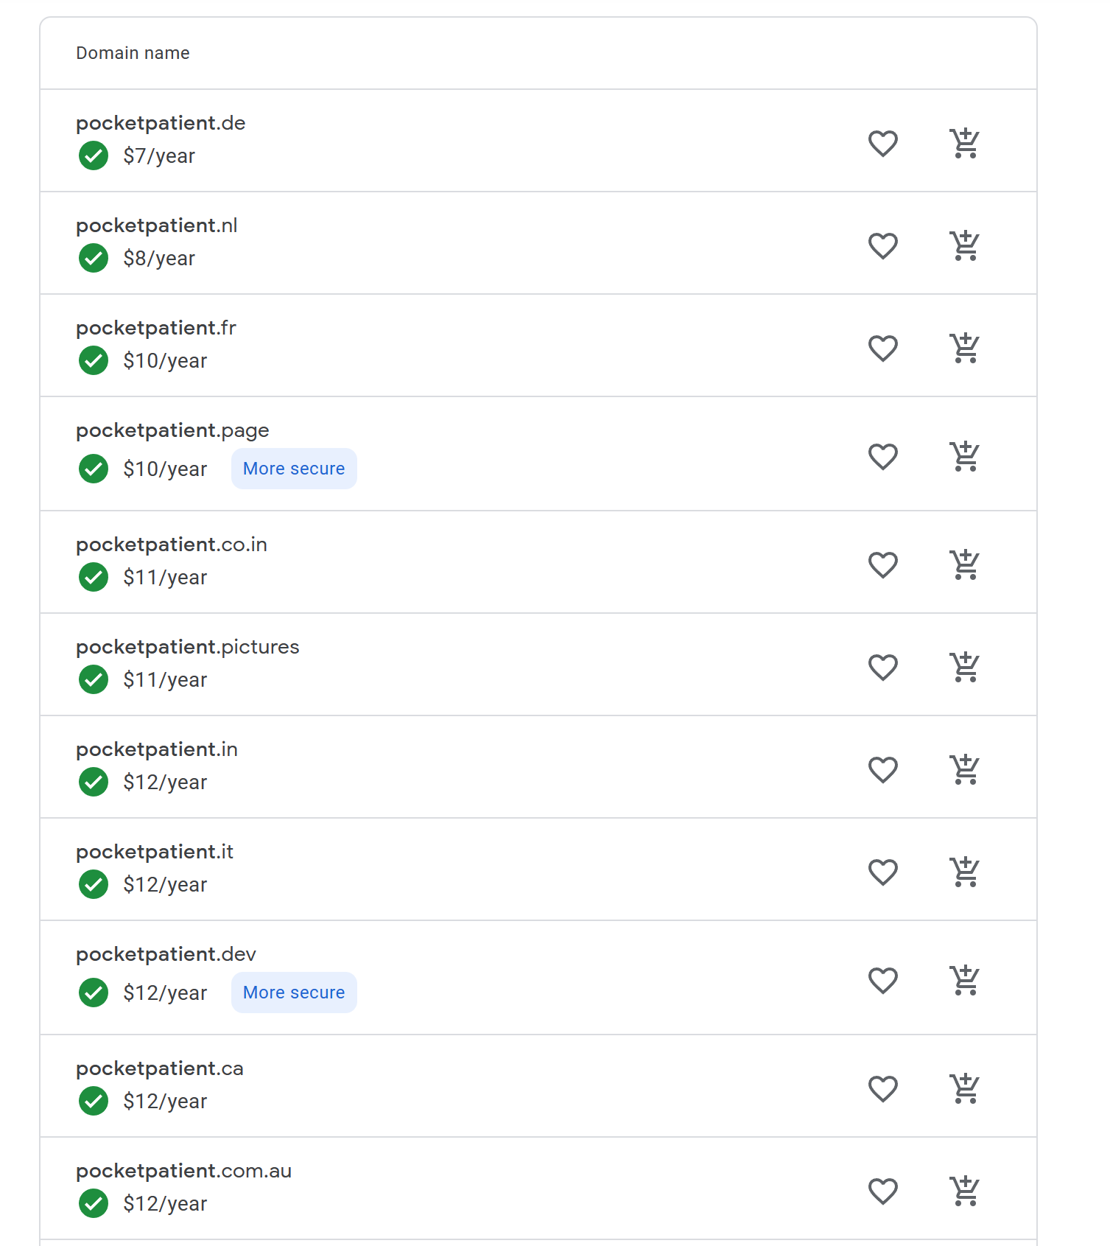

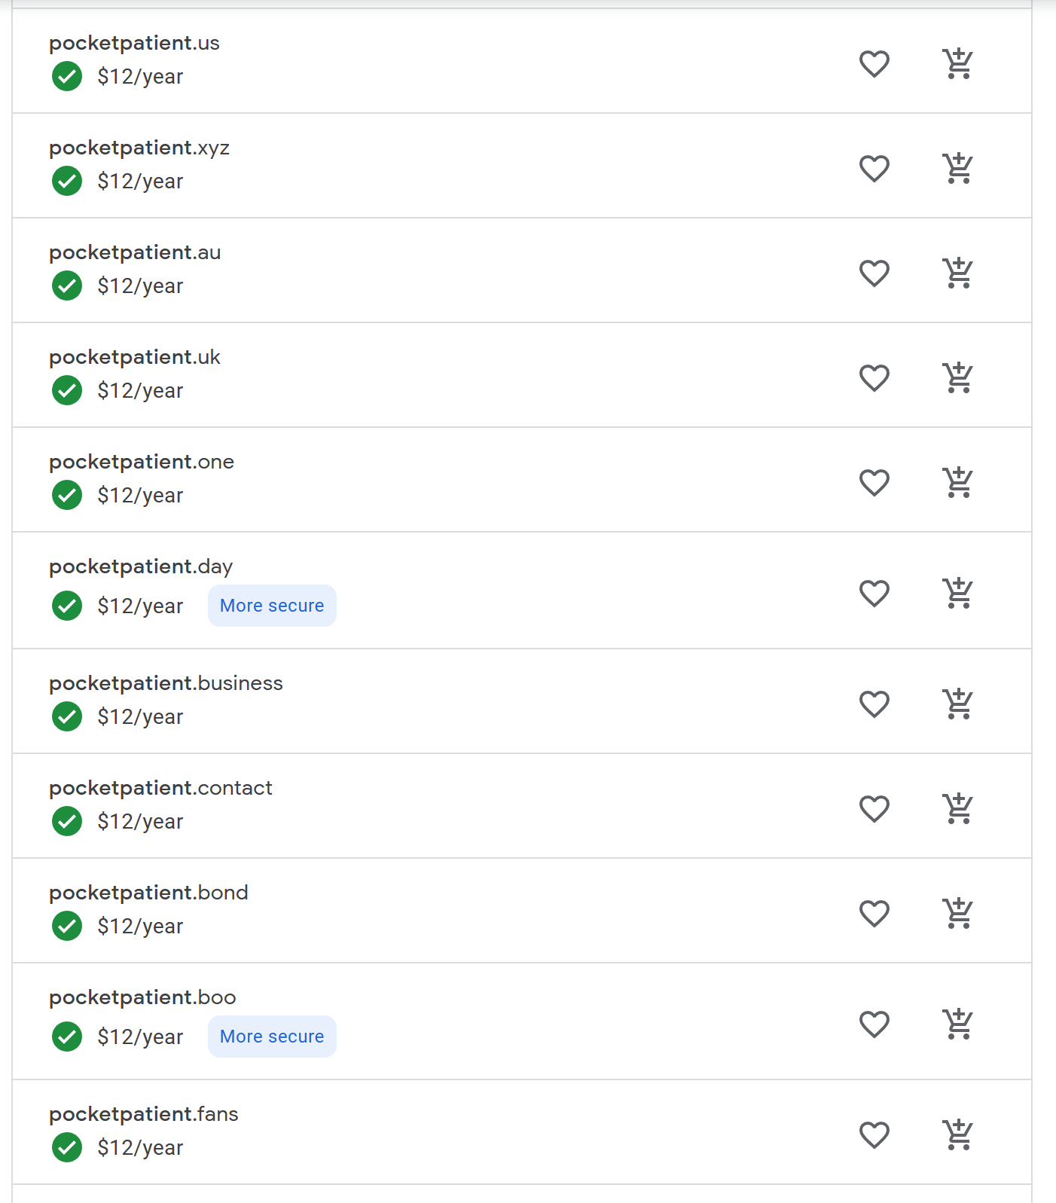

And after looking at the ending of the domain of pocketpatient.xx in the 7-12$ range, I think it would be reasonable to consider the cost of the domain to be 12$.

We would need to select a service provider to host our website for us, and here we would choose the Cloudflare’s Business plan for mass production, which cost $200 per month. We choose the business plan instead of the Free or Pro plan mainly because the business plan provides better support (has Chat option over the Pro plan, and has Chat + Tickets option over the Free plan). And the business plan also offers an uptime SLA of 100%, meaning that cloudflare will guarantee that your website will be up 100% of the time for people to access.

We would need a server to host our website information, I think that the Vultr S3 storage plan meets our need:

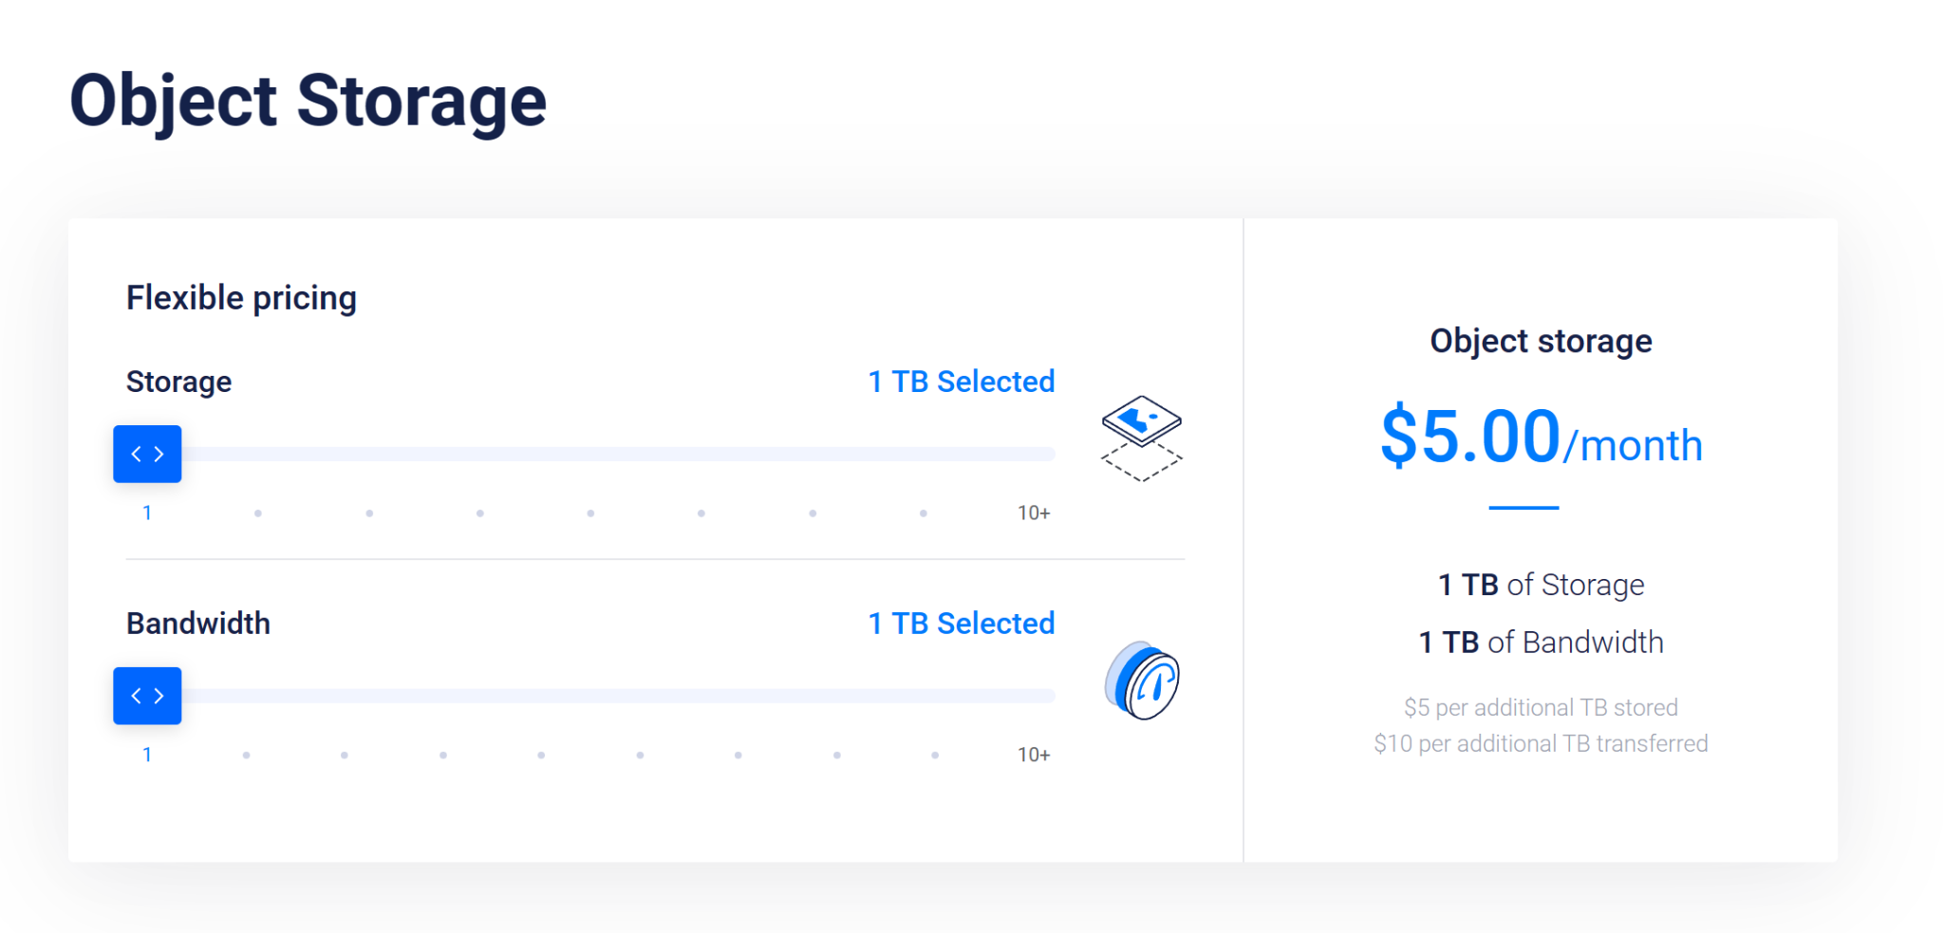

The plan starts at $5 per month and each additional TB of bandwidth costs $10 more and each additional TB of storage costs $5. Depending on how many people use our service, and how much bandwidth they use, the pricing with this part will start at $5 per month.

* 1. Cost saving of the product:

The service can be turned off every night and be available only during daytime for students to practice in order to save cost.

And if we can corporate with a big company/hospital to let them lend us their domain access, we could save the domain fee of $12 per year, say if we corporate with RWJBH, we could use addresses like rwjbh.org/pocketpatient to let users access our service.

* 1. Tax incentives to be considered towards final product cost
  2. Environmental aspects:

If we don’t have enough bandwidth and resources, people will have to wait for their turns before they can start practicing using our product, and because our product idea is very simple, and uses ChatGPT as backend, it would be very easy for other people to copy our idea and create their own version of our application, and therefore, our market share would be very vulnerable if we cannot provide enough bandwidth for users to use.

1. Social impact of the product:
   1. The developed product can have a positive impact on people with mental disorders, as our product can help the students in medical school to better prepare themselves when they are studying in university and lower the rate of mis-diagnosis when these students become doctors in the future.
   2. This product addresses the need of the medical school students to better prepare themselves for their intern career during their 3rd and 4th year of studies when they are in their first two years of studies.
   3. This product won’t change consumption patterns, as this product is not directly face towards mental disorder patients, this product would only help medical students become a better doctor.
   4. This product is not automating a task currently performed manually, and instead, it can help medical school students become more competitive in the job markets and help them find a better job quicker.
   5. Our product does not create new jobs or fields.
   6. Our product does not have any safety issues and won’t damage the user's health in any way.
   7. When making our product, because there are privacy concerns, illegal issues, and confidential issues, we cannot get our hands on real doctor and patient dialog documents to customize the ChatGPT model.

**V.** **Conclusion/Summary**

The Pocket Patient website, which has almost completed development, allows medical students to practice their diagnostic skills in mental disorders. The platform works with an artificial intelligence chatbot powered by GPT-3.5 turbo engine and implemented by programming language, Python and HTML & CSS. The program provides users with symptoms of mental disorders, and then they need to identify the name of the disorder and the corresponding treatment by text entry. We collected data on symptoms and treatments from the Mayo Clinic and Cleveland Clinic website.

The development process included tuning the language model, establishing a webpage, connecting webpage and the language model. To tune the model, prompt engineering techniques are applied, which is restructuring the natural languages. And content generated by the language model is examined by the data collected through Mayo Clinic and Cleveland Clinic website to ensure the correctness of content.We used HTML & CSS to write the webpage that could display text and input box where users can enter their answer. And to connect the model and webpage, we used the Python Flask package which will connect Python code and HTML.

Overall, the program is an innovative tool for medical students to practice their diagnostic skills for mental disorders. The artificial intelligence chatbot provides a simulated patient-like experience, which can help students gain more experience and confidence in diagnosing mental disorders.

For future development, the project can be improved by various ways like increasing the complexity of interaction between users and machines and better web page design for a pleasing experience. And we sincerely suggest focusing on getting the official data, for example the medical record or the conversation of psychotherapy in order to make the program more authentic and realistic as early as possible.

Last but not least, we want to mention the rationale for choosing mental disorder over physical disorder. Mental disorders can be more difficult to diagnose than physical disorders because symptoms can be less obvious and subjective. By developing a platform to practice diagnosing mental disorders, we are helping to increase the awareness of mental health. It can ultimately lead to better access to treatment.

##### **Acknowledgment *(Heading 5)***

Professor Anthony M. Tobia, Professor Hajar Shirley, Mr. Sasan Haghani, and Mr. Chung-Tse Michael Wu have given us selfless support and assistance in our process of developing Pocket Patient.

During the development of this project, your encouragement and support gave us great motivation to overcome all difficulties and challenges. You are not only our mentors, but also our friends and partners. I feel very lucky to have your support and help.

Finally, we would like to express our deep thanks and gratitude to all team members, Rui Zhang, Zhihang Liu, Jihao Yang, Mingkun Sun and Yuxi Yang. Thank you for helping each other. All efforts we put in together made our last semester at Rutgers a meaningful one.

##### **References**

[1] Mayo Clinic, “Mental illness”, <https://www.mayoclinic.org/diseases-conditions/mental-illness/symptoms-causes/syc-20374968>.

[2] Cleveland Clinic, “Mental health disorders: Types, diagnosis & treatment options”, <https://my.clevelandclinic.org/health/diseases/22295-mental-health-disorders>

[3] Libraries - OpenAI API. <https://platform.openai.com/docs/libraries>

[4] C. Greyling, “Example code & implementation considerations for GPT 3.5 turbo, CHATML & Whisper,” *Medium*, <https://cobusgreyling.medium.com/example-code-implementation-considerations-for-gpt-3-5-turbo-chatml-whisper-e61f8703c5db>

[5] Torres, C, “How to become a Psychiatrist - Insights into Psychiatry from UMHS school of medicine”, <https://www.umhs-sk.org/blog/become-a-psychiatrist>

#### [6] American Psychiatric Association, Diagnostic And Statistical Manual Of Mental Disorders, Fifth Edition, Text Revision (DSM-5-TR), <https://dsm.psychiatryonline.org/doi/book/10.1176/appi.books.9780890425787>

#### [7] [Lizzie Duszynski-Goodman](https://www.forbes.com/health/author/lizzie-duszynski-goodman/), Forbes Health, “Mental Health Statistics”, ​​<https://www.forbes.com/health/mind/mental-health-statistics/>

#### [8] Choosing a Career in Psychiatry, <https://www.psychiatry.org/residents-medical-students/medical-students/choosing-a-career-in-psychiatry>

#### [9] David C. Martin., “Clinical Methods: The History, Physical, and Laboratory Examinations. 3rd edition.”, Chapter 207: The Mental Status Examination

#### [10] Beatson JA, Bs MB, Rao S. “Depression and borderline personality disorder”. Journal of the Franklin Institute. 2012;61(1).

#### 